Copernicus
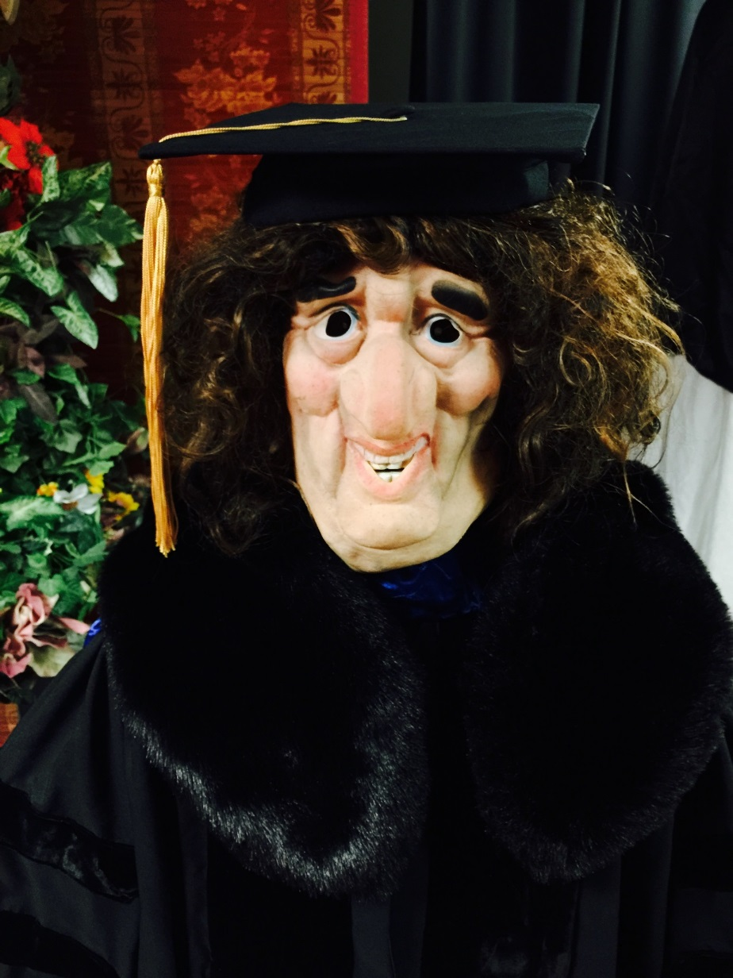
Task | Deadline | What to do | Who does it
1 |  | Build head with movable jaw and eyes (3DOF) | Tuna
2 |  | Build face using new mask technology that Tuna learned | Tuna
3 |  | Animate head | Tuna
4 |  | Animate complete left arm
5 |  | Animate complete right arm
6 |  | Animate complete upper body, no base.
7 |  | Repair the base
8 |  | Connect robot body to the base
9 |  | Program motions of the base
10 |  | Animate robot body with arms, head and base
11 |  | Lighting and sound for the robot performance.
12 |  | Kinect control using PowerPoint. Use my slides
13 |  | Copernicus song
14 |  | Conversation system
15 |  | Costume, hair, complete performance

Song about Copernicus.
You have to find the melody for it, may be modifying the text

Copernicus, Copernicus
Astronomy plus
Science fuss
Thus
Learn his story
Sing the glory

Copernicus was the guy
Who looked long to the sky
To the sky

He used to look long enough
Long enough
That he found an interesting stuff
Interesting stuff

He moved the Earth
He stopped the Sun
In the process he had fun

Through his knowledge acquisition
Fearful of the Inquisition
Was not burned on the stack
“Dying earlier” was his hack.

He was “The momento uno”
Later Kepler, later Bruno,
Gallileo, Leibniz, Newton,
Electricity, Photon, Proton.
Physics, Mechanics of Newton,
Science Evolution.

Airplanes, highways and Computers
Smartphones, rockets, Quantum ciphers

Science Evolution
Started with
Copernican revolution.

